

PHYSICIAN’S LEADERSHIP ACADEMY
2023-24

PUTTING YOUR LEADERSHIP JOURNEY TOGETHER

PUTTING YOUR LEADERSHIP JOURNEY TOGETHER
We’ve been working together for several months, and you’ve read about many concepts and gone on your individual leadership journey. The purpose of this exercise is to help you look back at the materials in a convenient way and to synthesize some of your thoughts and conclusions. For your convenience, we’ve provided links to brief session summaries and related videos in each section so that you can re-familiarize yourself with the material.

Date
Name

SECTION 1
Reading & Exercises
Mindshift Exercises
Unlocking Leadership Mindtraps
3 Vital Questions
Mindfulness for Beginners (John Kabat-Zinn)

- 4 -
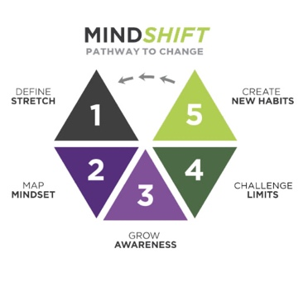
JOURNEY
CLICK FOR A SLIDE SUMMARY ON
MINDSHIFT

REFLECTIONS ON YOUR MINDSHIFT JOURNEY

- What was your one big thing at the beginning? Did it change over the course of the program? What is it now?
- What was your strongest limiting belief that you worked on?
- After completing the plot twist exercise and the loosening the narrative exercise, did your thoughts and feelings change at all about your limiting belief? How?
- What progress have you made on your one big thing?
- What experiments are you going to conduct to further loosen any limiting beliefs that remain?

CLICK FOR A SLIDE SUMMARY & VIDEOS ON LEADERSHIP MINDTRAPS

REFLECTIONS ON UNLOCKING LEADERSHIP MINDTRAPS

- Which of the leadership traps (you can choose more than one) do you fall into most?
- How do these traps show up in your everyday life?
- What progress have you made on being aware of the trap and getting yourself out of the traps?


CLICK FOR A SLIDE SUMMARY & VIDEOS
ON 3 VITAL QUESTIONS

REFLECTIONS ON THE 3 VITAL QUESTIONS

This book introduced several concepts:
- Above the Line/Below the Line
- Problem Orientation/Creative Orientation
- Drama Triangle (Victim, Persecutor, Rescuer)
- Empowerment Dynamic (Creator, Challenger, Coach)

- Which concepts resonated most with you and why?
- How have these “roles” shown up in your life?
- How has the awareness of these roles influenced your behavior?

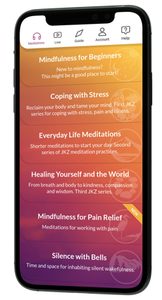
JKZ MOBILE APP AVAILABLE FROM APP STORE FOR YOUR MOBILE DEVICE

JON KABAT-ZINN JKZ MEDITATIONS

- What mindfulness concepts have you found the most helpful?
- What has caused you difficulty in increasing your mindfulness?
- What if any mindfulness practices have you tried and what has been the impact?

SECTION 2
Monthly Topics
Leadership Development
Listening
Trust
Relationship Building
Courageous Conversations
Leading Change

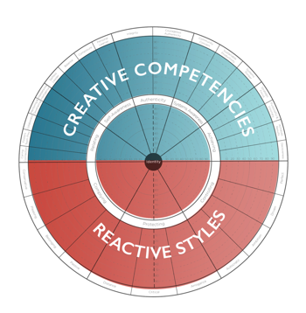
CLICK FOR A SLIDE SUMMARY & VIDEOS
ON LEADERSHIP DEVELOPMENT

INTRODUCTION TO LEADERSHIP DEVELOPMENT

WE COVERED A NUMBER OF LEADERSHIP TOPICS INCLUDING:
- Vertical and Horizontal Development
- Qualities of Effective Leaders
- Leadership Circle Profile Creative Competencies/Reactive Tendencies
- Awareness Precedes Choice which Precedes Change
- Putting down your life raft
What was your biggest Aha and what will you take away from this session?



LISTENING
CLICK FOR A SLIDE SUMMARY ON
LISTENING

LISTENING TOPIC S INCLUDED:
- Distracted
- Self-Centered
- Active
- Intuitive
- How our reactivity tendency affects the way we listen
What was your biggest Aha and what will you take away from this session?

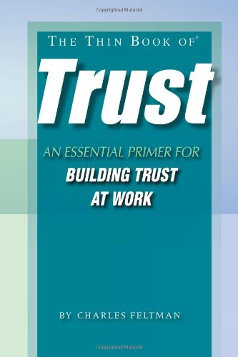

TRUST
CLICK FOR A SLIDE SUMMARY ON TRUST
THE THIN BOOK OF TRUST TOPICS INCLUDED:
- Sincerity
- Reliability
- Competency
- Care
- Confronting Trust Issues

What was your biggest Aha and what will you take away from this session?


CLICK FOR A SLIDE SUMMARY
ON RELATIONSHIP BUILDING

RELATIONSHIP BUILDING

RELATIONSHIP BUILDING (FOUR TOXINS)
- Criticism
- Defensiveness
- Contempt
- Stonewalling
- Antidotes to each (Handout)
- Active Constructive Responding
What was your biggest Aha and what will you take away from this session?

COURAGEOUS COVERSATIONS
- Prepare
- Dig out a Gem
- Are you Ready?
- Call a friend
- Start the Conversation
- Listen and Talk
- Close the conversation
What was your biggest Aha and what will you take away from this session?

CLICK FOR A SLIDE SUMMARY ON
COURAGEOUS CONVERSATIONS

COURAGEOUS CONVERSATIONS


CLICK FOR A SLIDE SUMMARY ON
LEADING CHANGE

LEADING CHANGE

LEADING CHANGE
- Change Style Indicator
- 4 Stages of Change

What was your biggest Aha and what will you take away from this session?

SECTION 3
Assessments
Leadership Circle Profile
Emergenetics
Change Style Preference

LEADERSHIP CIRCLE PROFILE

- CREATIVE COMPETENCIES
- REACTIVE TENDENCIES

Which creative competency are you most proud of? How are you going to leverage it going forward to improve your leadership?
Which reactive tendency has given you the most problems? How have you improved in this area? What more are you going to do to minimize this tendency?



EMERGENETICS

 | WHAT WERE YOUR PREFERENCES & PERCENTILES?
 | Thinking Preferences  Analytical %_____  Structural %_____  Social %_____  Conceptual %_____ | Behavioral Percentiles  Expressive_____  Assertive_____  Flexibility_____
How do you see your thinking and behavioral preferences show up in your work and life?
Does your work allow you to leverage your preferences? If so, how? If not, what can you do to bring these preferences into your work?

CHANGE STYLE PREFERENCE

 | WHAT IS YOUR CHANGE STYLE?
 | 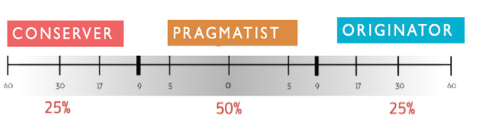 | Are you an  Originator____  Pragmatist____  Conserver____
How does your change style preference show up in your work and in your life?
What are you going to do to make sure you don’t get stuck in your change preference?

