Name: |  |  | Date:

Now that you have your ONE BIG THING and have taken a SELF INVENTORY of the behaviors that you do instead of your OBT, in this exercise we turn our focus to drill down into the mindset – revealing your inner game.
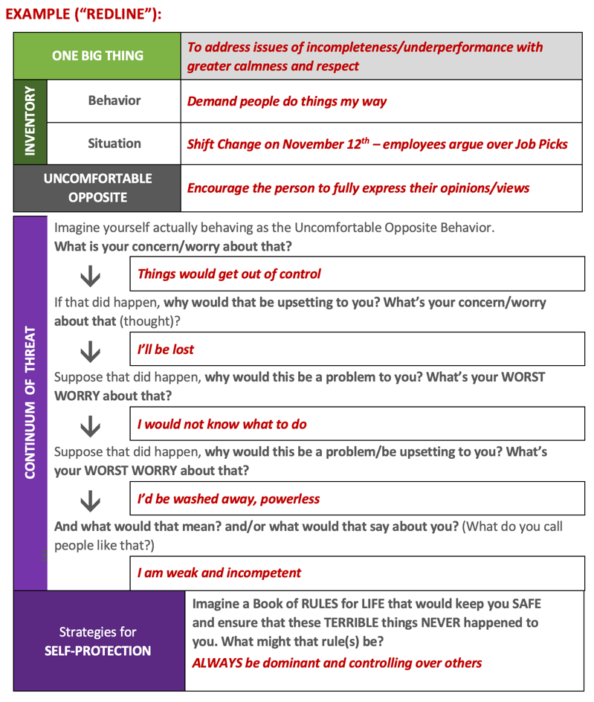
In this exercise you will start with the Self Inventory you completed, taking each behavior/ situation/uncomfortable opposite, and then answer the series of drill down questions to examine the underlying worries and concerns and uncover intermediate-level and core beliefs.
Things to keep in mind as you complete your drill downs:
Expect to experience increasing levels of threat the deeper you drop.
You know you are doing good work in your drill downs when you experience some, or all, of the following…
- They reveal a threat to your self-image, identify and/or ego – how you’d prefer to be seen.
- They reveal a side of you that you’d rather keep hidden (a.k.a. “dreaded image”).
- They contain actual expressions of your inner voice and/or your inner critic.
Note: the deepest and darkest threat is to you alone - not to your organization or others.
BEHAVIOR 01
“This heroic transformative journey happens when we give ourselves over to the pull of purpose and ride the Descending Current down to where we see the illusion of our Reactive Self.”
Bob Anderson, Founder | The Leadership Circle
ONE BIG THING |  | [insert here]
INVENTORY | Behavior | [insert here]
INVENTORY | Situation | [insert here]
UNCOMFORTABLE OPPOSITE |  | [insert here]

CONTINUUM OF THREAT  W | Imagine yourself actually behaving as the Uncomfortable Opposite Behavior.  What is your concern/worry about that?
CONTINUUM OF THREAT  W |  | [insert here]
CONTINUUM OF THREAT  W | If that did happen, why would that be upsetting to you? What’s your concern/worry  about that (thought)?
CONTINUUM OF THREAT  W |  | [insert here]
CONTINUUM OF THREAT  W | Suppose that did happen, why would this be a problem to you? What’s your WORST WORRY about that?
CONTINUUM OF THREAT  W |  | [insert here]
CONTINUUM OF THREAT  W | Suppose that did happen, why would this be a problem/be upsetting to you? What’s  your WORST WORRY about that?
CONTINUUM OF THREAT  W |  | [insert here]
CONTINUUM OF THREAT  W | And what would that mean? and/or what would that say about you? (What do you call  people like that?)
CONTINUUM OF THREAT  W |  | [insert here]
Strategies for  SELF-PROTECTION (“Always…” /”Never…” ) |  |  | Imagine a Book of RULES for LIFE that would keep you SAFE and ensure that these TERRIBLE things NEVER happened to you. What might that rule(s) be? [Brainstorm a few here]
LIMITING BELIEF  IF [opposite of Strategy/Rule actually occurs]  THEN [worst nightmare] |  |  | Imagine not protecting yourself and doing the opposite of the Rule. What are you afraid might happen (worst worry/nightmare)?

BEHAVIOR 02
ONE BIG THING |  | [insert here]
INVENTORY | Behavior | [insert here]
INVENTORY | Situation | [insert here]
UNCOMFORTABLE OPPOSITE |  | [insert here]

CONTINUUM OF THREAT  W | Imagine yourself actually behaving as the Uncomfortable Opposite Behavior.  What is your concern/worry about that?
CONTINUUM OF THREAT  W |  | [insert here]
CONTINUUM OF THREAT  W | If that did happen, why would that be upsetting to you? What’s your concern/worry  about that (thought)?
CONTINUUM OF THREAT  W |  | [insert here]
CONTINUUM OF THREAT  W | Suppose that did happen, why would this be a problem to you? What’s your WORST WORRY about that?
CONTINUUM OF THREAT  W |  | [insert here]
CONTINUUM OF THREAT  W | Suppose that did happen, why would this be a problem/be upsetting to you? What’s  your WORST WORRY about that?
CONTINUUM OF THREAT  W |  | [insert here]
CONTINUUM OF THREAT  W | And what would that mean? and/or what would that say about you? (What do you call  people like that?)
CONTINUUM OF THREAT  W |  | [insert here]
Strategies for  SELF-PROTECTION (“Always…” /”Never…” ) |  |  | Imagine a Book of RULES for LIFE that would keep you SAFE and ensure that these TERRIBLE things NEVER happened to you. What might that rule(s) be? [Brainstorm a few here]
LIMITING BELIEF  IF [opposite of Strategy/Rule actually occurs]  THEN [worst nightmare] |  |  | Imagine not protecting yourself and doing the opposite of the Rule. What are you afraid might happen (worst worry/nightmare)?

BEHAVIOR 03
ONE BIG THING |  | [insert here]
INVENTORY | Behavior | [insert here]
INVENTORY | Situation | [insert here]
UNCOMFORTABLE OPPOSITE |  | [insert here]

CONTINUUM OF THREAT  W | Imagine yourself actually behaving as the Uncomfortable Opposite Behavior.  What is your concern/worry about that?
CONTINUUM OF THREAT  W |  | [insert here]
CONTINUUM OF THREAT  W | If that did happen, why would that be upsetting to you? What’s your concern/worry  about that (thought)?
CONTINUUM OF THREAT  W |  | [insert here]
CONTINUUM OF THREAT  W | Suppose that did happen, why would this be a problem to you? What’s your WORST WORRY about that?
CONTINUUM OF THREAT  W |  | [insert here]
CONTINUUM OF THREAT  W | Suppose that did happen, why would this be a problem/be upsetting to you? What’s  your WORST WORRY about that?
CONTINUUM OF THREAT  W |  | [insert here]
CONTINUUM OF THREAT  W | And what would that mean? and/or what would that say about you? (What do you call  people like that?)
CONTINUUM OF THREAT  W |  | [insert here]
Strategies for  SELF-PROTECTION (“Always…” /”Never…” ) |  |  | Imagine a Book of RULES for LIFE that would keep you SAFE and ensure that these TERRIBLE things NEVER happened to you. What might that rule(s) be? [Brainstorm a few here]
LIMITING BELIEF  IF [opposite of Strategy/Rule actually occurs]  THEN [worst nightmare] |  |  | Imagine not protecting yourself and doing the opposite of the Rule. What are you afraid might happen (worst worry/nightmare)?

BEHAVIOR 04
ONE BIG THING |  | [insert here]
INVENTORY | Behavior | [insert here]
INVENTORY | Situation | [insert here]
UNCOMFORTABLE OPPOSITE |  | [insert here]

CONTINUUM OF THREAT  W | Imagine yourself actually behaving as the Uncomfortable Opposite Behavior.  What is your concern/worry about that?
CONTINUUM OF THREAT  W |  | [insert here]
CONTINUUM OF THREAT  W | If that did happen, why would that be upsetting to you? What’s your concern/worry  about that (thought)?
CONTINUUM OF THREAT  W |  | [insert here]
CONTINUUM OF THREAT  W | Suppose that did happen, why would this be a problem to you? What’s your WORST WORRY about that?
CONTINUUM OF THREAT  W |  | [insert here]
CONTINUUM OF THREAT  W | Suppose that did happen, why would this be a problem/be upsetting to you? What’s  your WORST WORRY about that?
CONTINUUM OF THREAT  W |  | [insert here]
CONTINUUM OF THREAT  W | And what would that mean? and/or what would that say about you? (What do you call  people like that?)
CONTINUUM OF THREAT  W |  | [insert here]
Strategies for  SELF-PROTECTION (“Always…” /”Never…” ) |  |  | Imagine a Book of RULES for LIFE that would keep you SAFE and ensure that these TERRIBLE things NEVER happened to you. What might that rule(s) be? [Brainstorm a few here]
LIMITING BELIEF  IF [opposite of Strategy/Rule actually occurs]  THEN [worst nightmare] |  |  | Imagine not protecting yourself and doing the opposite of the Rule. What are you afraid might happen (worst worry/nightmare)?

BEHAVIOR 05
ONE BIG THING |  | [insert here]
INVENTORY | Behavior | [insert here]
INVENTORY | Situation | [insert here]
UNCOMFORTABLE OPPOSITE |  | [insert here]

CONTINUUM OF THREAT  W | Imagine yourself actually behaving as the Uncomfortable Opposite Behavior.  What is your concern/worry about that?
CONTINUUM OF THREAT  W |  | [insert here]
CONTINUUM OF THREAT  W | If that did happen, why would that be upsetting to you? What’s your concern/worry  about that (thought)?
CONTINUUM OF THREAT  W |  | [insert here]
CONTINUUM OF THREAT  W | Suppose that did happen, why would this be a problem to you? What’s your WORST WORRY about that?
CONTINUUM OF THREAT  W |  | [insert here]
CONTINUUM OF THREAT  W | Suppose that did happen, why would this be a problem/be upsetting to you? What’s  your WORST WORRY about that?
CONTINUUM OF THREAT  W |  | [insert here]
CONTINUUM OF THREAT  W | And what would that mean? and/or what would that say about you? (What do you call  people like that?)
CONTINUUM OF THREAT  W |  | [insert here]
Strategies for  SELF-PROTECTION (“Always…” /”Never…” ) |  |  | Imagine a Book of RULES for LIFE that would keep you SAFE and ensure that these TERRIBLE things NEVER happened to you. What might that rule(s) be? [Brainstorm a few here]
LIMITING BELIEF  IF [opposite of Strategy/Rule actually occurs]  THEN [worst nightmare] |  |  | Imagine not protecting yourself and doing the opposite of the Rule. What are you afraid might happen (worst worry/nightmare)?

